ALICE IN WONDERLAND  
NM3228

Group 5

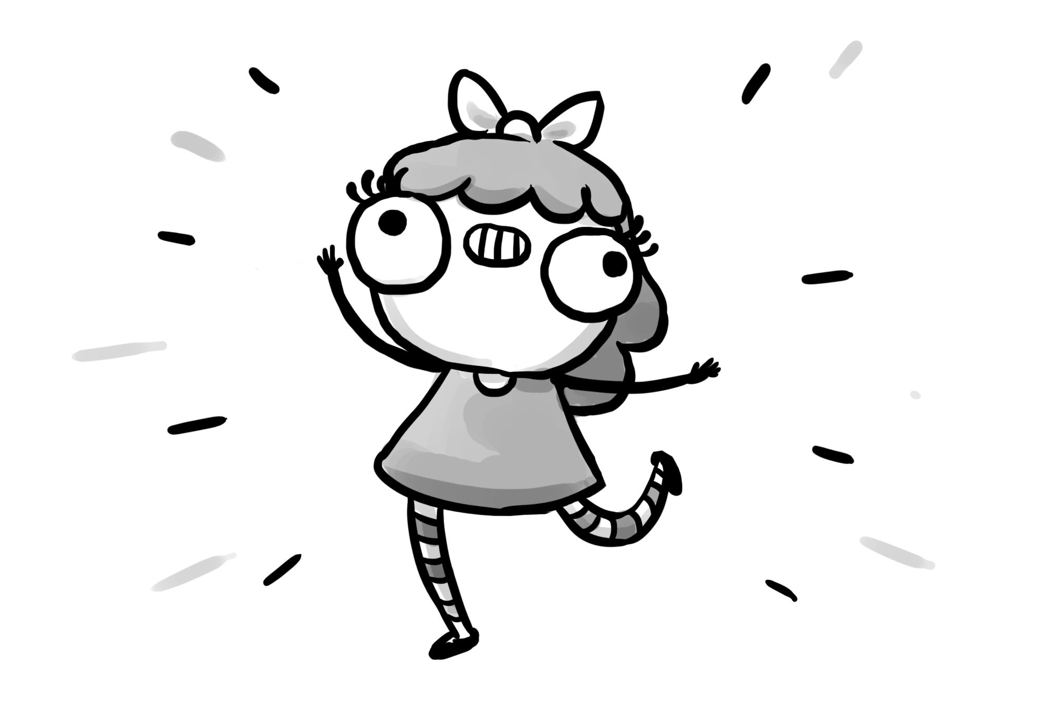

# Table of Contents

Table of Contents 2

Who We Are 4

Our Prototype: 4

The Beginning 5

Brainstorming 5

Conceptualization 5

Discussion 5

Key Scene Distribution 5

Technical Focus 5

Story Moral 6

Narrative Structures 6

The Content 6

Characters 6

Notable Items and References 6

The Plot 7

White Rabbit Scene 7

Hallway of Infinite Doors Scene 7

Morpheus the Caterpillar Scene 7

Cheshire Cat Scene 7

Mad Hatter/March Hare Tea Party Scene 7

Queen’s Dungeon Scene 7

Narrative Structure 7

Multipath Narrative 8

Sequential Art Language 8

Panel to Panel Transitions 8

Subject-to-Subject Transitions 8

Action-to-Action Transitions 9

Moment-to-Moment Transitions 9

Time and Space 10

Through Motion 10

Through Sound 11

Images and Text 12

Design and Layout 13

Principle Design Concepts 13

Compositions 13

Color Scheme 14

Components of Web Features 14

Interactivity 14

Dilemma 14

False Choices 14

Sound and Audio 14

Animation 14

Tools and Techniques 15

Testing and Deployment 15

Initial Testing 15

Key Observations 15

Insights 15

Changes Made 15

Follow Up Testing 16

Reflection 16

Problems encountered 16

Lessons gained 16

Transferable Knowledge and Skills 16

# Who We Are

|  |  |
| --- | --- |
| <Insert Pic Here>  See Wenhan  A0122498Y  ?  [walrus@hotmail.sg](mailto:walrus@hotmail.sg) | <Insert Pic Here>  Lei Mingyu  A0119447Y  ?  [mingyu@u.nus.edu](mailto:mingyu@u.nus.edu) |
| <Insert Pic Here>  Phan Shi Yu  A0091024U  ?  [A0091024@u.nus.edu](mailto:A0091024@u.nus.edu) | **<Insert Pic Here>**  **Andrew Bryan Kiflie**  **A0088250E**  **91384479**  [**a0088250@u.nus.edu**](mailto:a0088250@u.nus.edu) |

# Our Prototype:

This work provides a dark twist to the well known story of Alice in Wonderland. Our iteration has Alice as a hyperactive child who has had too much candy. Due to the overwhelming sugar rush, she starts to hallucinate, with the rest of the story following her deeds (and misdeeds) in the world of Wonderland as she attempts to chase down the mysterious Cake. The interactivity of the webcomic allows for readers to choose different paths to follow based on the actions the reader chooses for Alice. Intending to impart a moral lesson to the readers, these paths lead to multiple endings, with the different endings showing the reader the effects and consequences of their actions.

BE WARNED: You are advised to read the story prior to reading this document, as major plot points and spoilers will be present throughout the document, that may interfere with your ability to properly enjoy the story to its fullest.

# The Beginning

## Brainstorming

In the first meeting, the members all contributed to a pool of Disney movies to choose from. The list was subsequently narrowed down and each member chose the movie they were most familiar with to consider and subsequently come up with a basic story structure for.

The final distribution of movies was as follows:

|  |  |
| --- | --- |
| Group Member | Movie Name |
| Wenhan | Alice In Wonderland |
| Andrew | Finding Nemo |
| Shi Yu | ?? |
| Mingyu | ?? |

It was these ideas that subsequently went on to be further developed into our individual Assignment 4.

## Conceptualization

It was only on the critique session of our Assignment 4 that we were able to come to a conclusion on which movie to focus on.

In addition to the 20 panel story that he had come up with for his own A4, Wenhan had also drafted a basic story structure for us to discuss upon during the meeting. The intial draft was well received by the rest of the group, and was susequently initiated as the key storyline.

The initial draft consisted of the following key scenes:

* Helping the White Rabbit
* Meeting with the Cheshire
* Choosing the red or blue pill from Morpheus
* Hallway of Endless Doors

## Discussion

### Key Scene Distribution

The rest of the key scenes were decided upon and each of us were assigned one to two scenes to flesh out. After each scene had been fleshed out, they were passed on to the Story team to be conceptualized and then drawn.

### Technical Focus

Over the next few meetings, it was also decided that due to the strong presence of Computing students in our group, we would have a stronger technical focus on our project. Thus, we split the work into two: Wenhan and Andrew would concentrate on the story and documentation, whilst Mingyu and Shi Yu would focus on the technical aspect of the project, giving the project a more polished look to it.

### Story Moral

From the initial draft, the idea was to have an inherent moral to be imparted upon our readers. Alice was a character stuck in Wonderland ever time she lost control and fell to her Greed. We wanted readers to see that control over yourself is important: Moderation is Key. The story was carefully crafted with this moral in mind, and subsequently, we even factored in the use of a well known analogy of the Seven Deadly Sins in order to not only bring in some character depth, but also to reinforce the moral of self-control.

# Narrative Structures

## The Content

### Characters

There are a total of 7 characters within the story. As mentioned above, each character is attributed to one of the Seven Deadly Sins, with the idea of giving the individual characters some depth. That said, due to the limitations of the number of panels allowed, the characters could not be fleshed out as deeply as we would have liked.

The characters are as follows:

Alice – Greed:

Greedy Alice always tries to get her hands on anything sweet that comes her way. Maybe that’s why she’s always so energetic

White Rabbit – Sloth:

The time-lord, cursed by the Red Queen. Ensures that  time keeps moving. Alice tries to “follow the white rabbit” but always fails.

Cheshire – Envy:

The only one who knows everything about Wonderland. Neutral: does not side with the Queen or help the children. Toys around with Alice

Morpheus – Gluttony:

Morpheus the caterpillar. Introduces the Cake to Alice. Works for the Queen.

Pride – Prof Hatter:

Mad theoretical physicist who was responsible for the time loop which resulted in the Tea Party Paradox. Still refuses to admit it.

March Hare – Lust:

Muscular, bodybuilding hare that knows he looks good.

Queen of Hearts – Wrath:

The Queen of Hearts. Like, literally. Lives off the souls of children stuck in Wonderland. Those who find their way to her castle will be trapped there for eternity.

### Notable Items and References

Within the story are certain items or dialogue that are referenced from not only the story of Alice in Wonderland, but from many other famous sources from current media. These references do not directly influence the flow of the plot, but do give readers who are aware of the connections a more inclusive experience(very much like an inside joke).

The list of references is as follows:

* The pocket watch(reimagined as a giant clock) of the White Rabbit from Alice in Wonderland
* The Shrinking Drink from Alice in Wonderland
* A literal Queen of Hearts
* Morpheus and the Blue/Red Pill from The Matrix
* ‘Going Subatomic’ from Antman
* ‘Pokemon Battle Animation’ from Pokemon
* Landing on the Cheshire from Totoro?
* The Fez, worn by the Eleventh Doctor in Dr Who
* ‘It’s dangerous, Take this!’ from Legend of Zelda
* The Portal Gun, from Portal
* ‘The Cake is a Lie’ from Portal
* ‘Bam,Pow,etc’ from old Batman cartoons
* Schroedinger’s Cat
* ‘It’s not you, it’s me’, a recognized line used for breakups

## The Plot

The story follows Alice as she travels through Wonderland. Each scene requires the user to make a choice in order to proceed.

### White Rabbit Scene

Also the starting scene, the scene introduces Alice, as well as the concept and environment of Wonderland. Alice immediately encouters the white rabbit as she enters Wonderland, and must make the decision of wheter to help the rabbit or follow behind it.

### Hallway of Infinite Doors Scene

Alice finds herself in the hallway of infinite doors. No matter how many doors she attempts to walk through, she ends up back where she started. If she consistently travels down the corridor however, she ends up at the end, and is given a choice of taking either a cake, or a potion.

### Morpheus the Caterpillar Scene

Alice finds herself in a mushroom field. There, she encounters the caterpillar Morpheus. He offers her two pills, red and blue. The Blue Pill is her the opportunity to leave Wonderland, whilst choosing the Blue Pill is choosing to stay in Wonderland to hunt down the Cake.

### Cheshire Cat Scene

This scene gives Alice(and the reader) some exposition on the state of Wonderland. The Cheshire teases Alice with the lure of the Cake, and she has to decide whether to continue on or to crawl into the Cheshire’s mouth to escape.

### Mad Hatter/March Hare Tea Party Scene

Found in an alternate dimension, the Mad Hatter and the March Hare are both trapped in a time loop due to the Mad Hatter’s experiments. The Mad Hatter entrusts Alice with the task of obtaining three objects that he needs in order to fix the clock and thus escape from the time loop.

If Alice obtains all three items, he sends her forward into the Queen’s Dungeon. If not, he will send her back in time(to the beginning of her adventures) to collect the items.

### Queen’s Dungeon Scene

Alice is able to see the rest of the trapped children’s souls that the Queen has captured. She is then confronted by the Queen and forced to fight. Depending on the reader’s choices, Alice can either beat the Queen and sbusequently free all the children, or end up being captured herself.

## Narrative Structure

Our project loosely follows the Classical 3-Act Structure as described in our lecture notes.

Act One is depicted during the White Rabbit Scene, with the world of Wodnerladn being introduced, together with Alice, our main protagonist.

The Hallway Scene, Cheshire Scene and Caterpillar Scene all belong to Act Two, building up to the climax of Act 2 in the Tea Party Scene.

Finally, the resolution comes in Act 3 when Alice confronts the Queen in the Queen’s Dungeon Scene.

Referring to Neil Cohn’s Basic Narrative Structure, each scene corresponds to a phase, with each phase consisting of an establishing panel, an initial panel, a peak panel, with several prolongational panels. Some phases also have a release panel. One example of this phase structure can be seen below.

<insert phase for White Rabbit>

## Multipath Narrative

Our story utilises the foldback structure model, specifically the Parallel Path structure. This is because each choice made by the reader eventually(unless they reach a point that brings them back to the start) leads to the Tea Party Scene. However, the choices made by readers will affect the direction and content that they are able to interact with prior to arriving at the Tea Party Scene. A general overview of the path for our narrative is as follows:

<Insert flow chart here>

# Sequential Art Language

## Panel to Panel Transitions

Majority of our project consists of action-to-action(ATA) or subject-to-subject(STS) transitions.

Though we had intended to include a few moment-to-moment(MTM) transitions, we realised that in order to work within the limit of 90 panels, several of the planned moment-to-moment panels had to be reduced. Aspect-to-aspect and non-sequitor transitions are not used within our project.

### Subject-to-Subject Transitions

The main bulk of our transitions, we used to STS transitions usually to carry on the flow of the story. STS transitions allow us to show interactions between the characters, as well as be able to shift from Alice to her surroundings so that readers can be aware of the environment Alice is interacting with.

This is especially important in the Tea Party Scene, where we can see the interactions between Alice, the Mad Hatter and the March Hare through STS transitions from one character to another.

<Inserrt Tea party march hare talking with mad hatter.>

### Action-to-Action Transitions

ATA transitions are mainly used to portray the character’s actions within the story. Like in the picture below, we see Alice jumping off the furry mound she was on. IN the next panel, we see her land, and at the same time see her noticing that what she had landed on was a cat. The transition allows for the character’s actions to be easily understood by the readers.

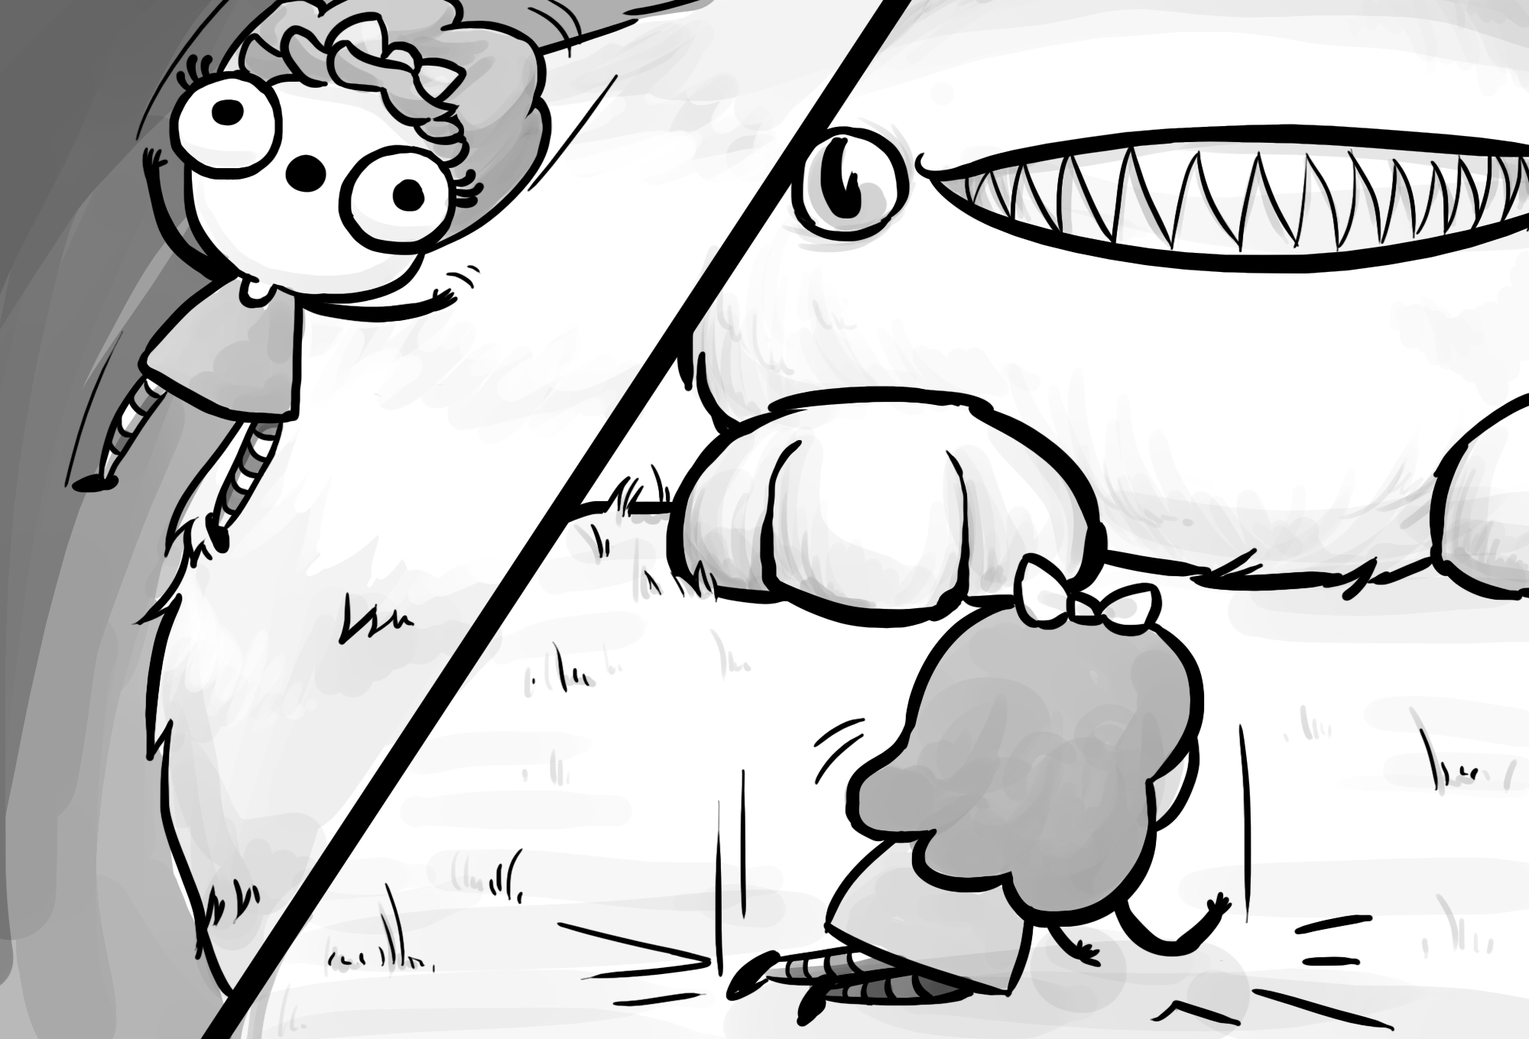

### Moment-to-Moment Transitions

We utilise MTM transitions in order to bring attention the reader’s attention to a specific action. One example(shown below) is when the White Rabbit gets hit by the curse. The four panels have a MTM transition, breaking the progression of the rabbit growing old into four parts to place further emphasis upon the readers.

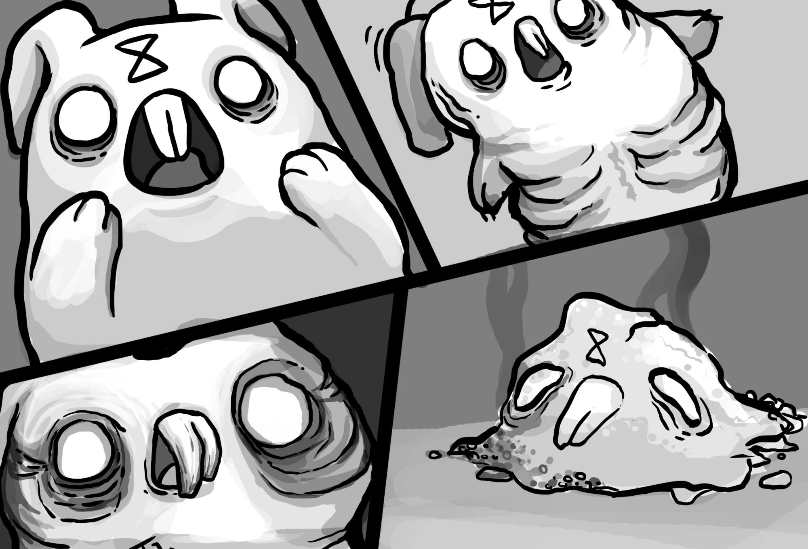

Scene-to-Scene Transitions

Few scene to scene transitions are used, mainly due to the fact that the story closely follows a single character(Alice) within a short amount of time. However, with the exception of one(see below), all scene-to-scene transitions occur when Alice ends up returning back to the real world.

Below is an example of scene-to-scene transition. Trapped by the hearts, the next scene is one that is dark with visual text depicting a fight. Finally, the third panel shows Alice standing alone, the hearts on the ground. The transition requires readers to infer that Alice was able to overpower and defeat the hearts, within an indetermined amount of time.

<Insert Alice fight hearts>

## Time and Space

### Through Motion

There are several ways within our work that utilise motion to depict time.

One way is in the use of motion lines. Most actions that are supposed to depict fast movement are accompanied by motion lines to allow reaers to get a feel that the characters are moving fast. One example is when Alice falls down the throat of the Cheshire, shown below.

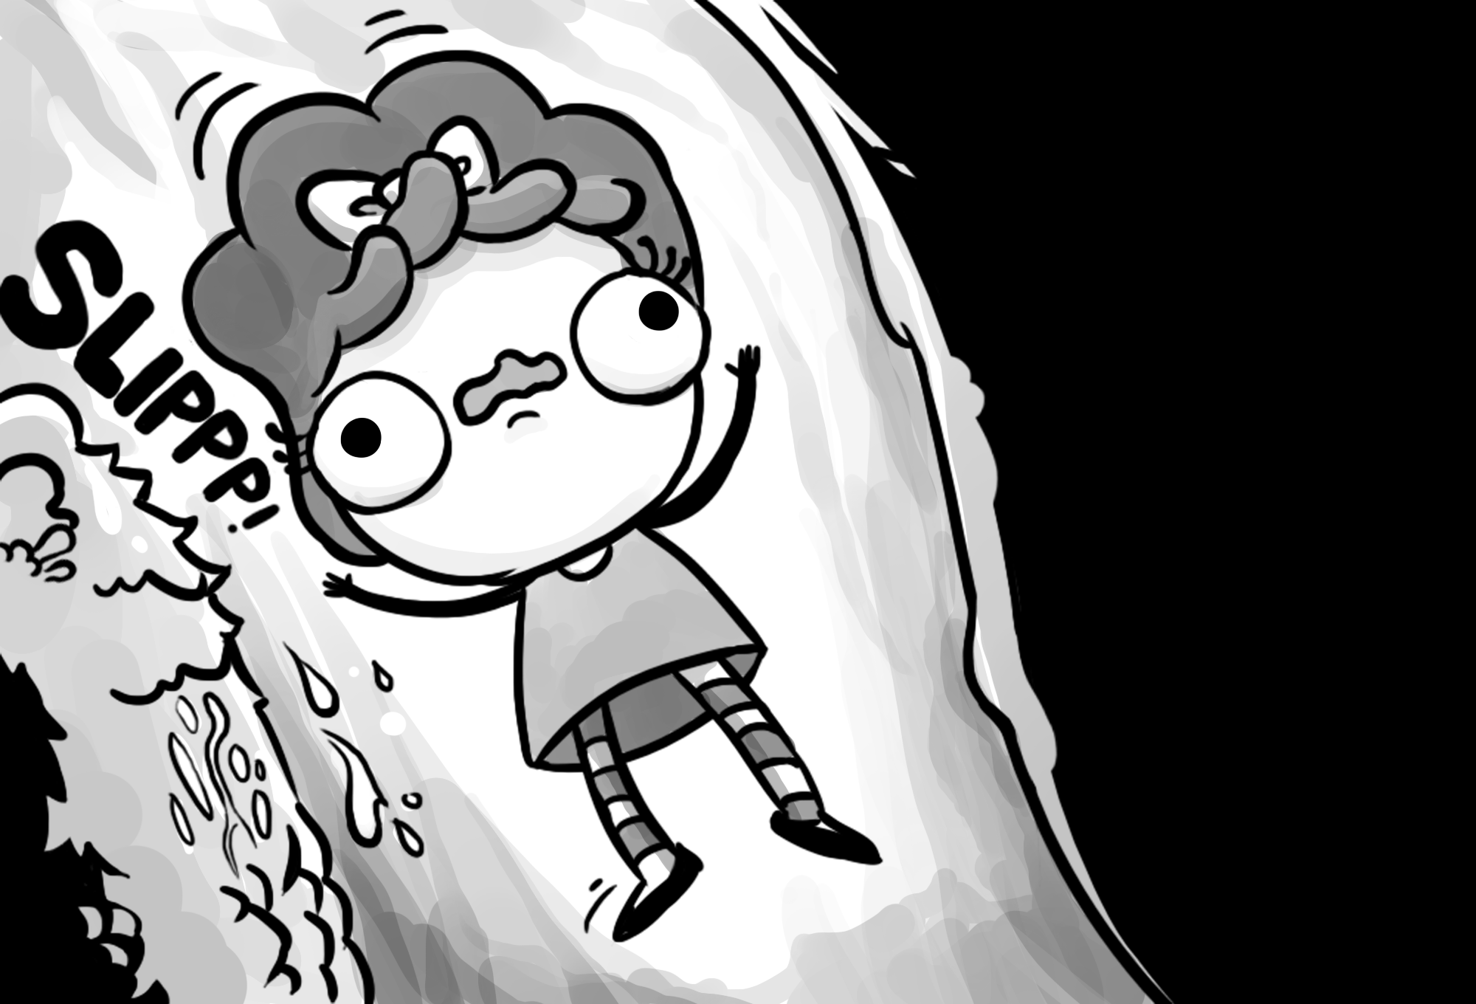

In addition, we utilised the ‘afterimages’ concept to depict a slowing down on time when Alice ends up chasing after the White Rabbit.

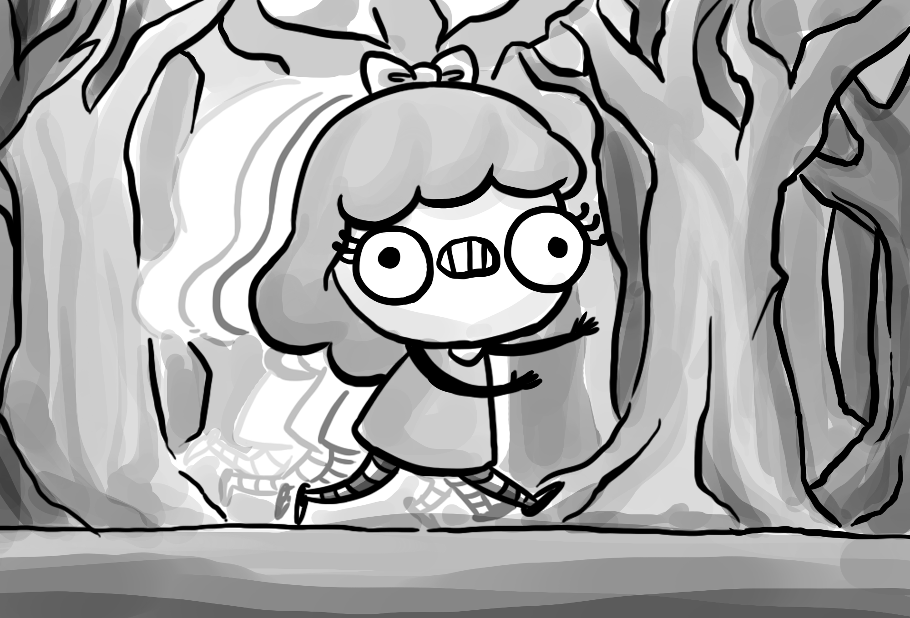

### Through Sound

Sound is used heavily in our project to give the readers a sense that the panels are just snapshots in time.

Speech bubbles are used when characters communicate, giving the panel a timing of hwoever the sentence is.

In addition, many actions are accompanied by a text sound effect. The reader reads the sound and is able to associate it with the action performed, thus giving the action a sense of motion and time. In the picture below, the sound effects help us to understand that the actions happen one after the other.

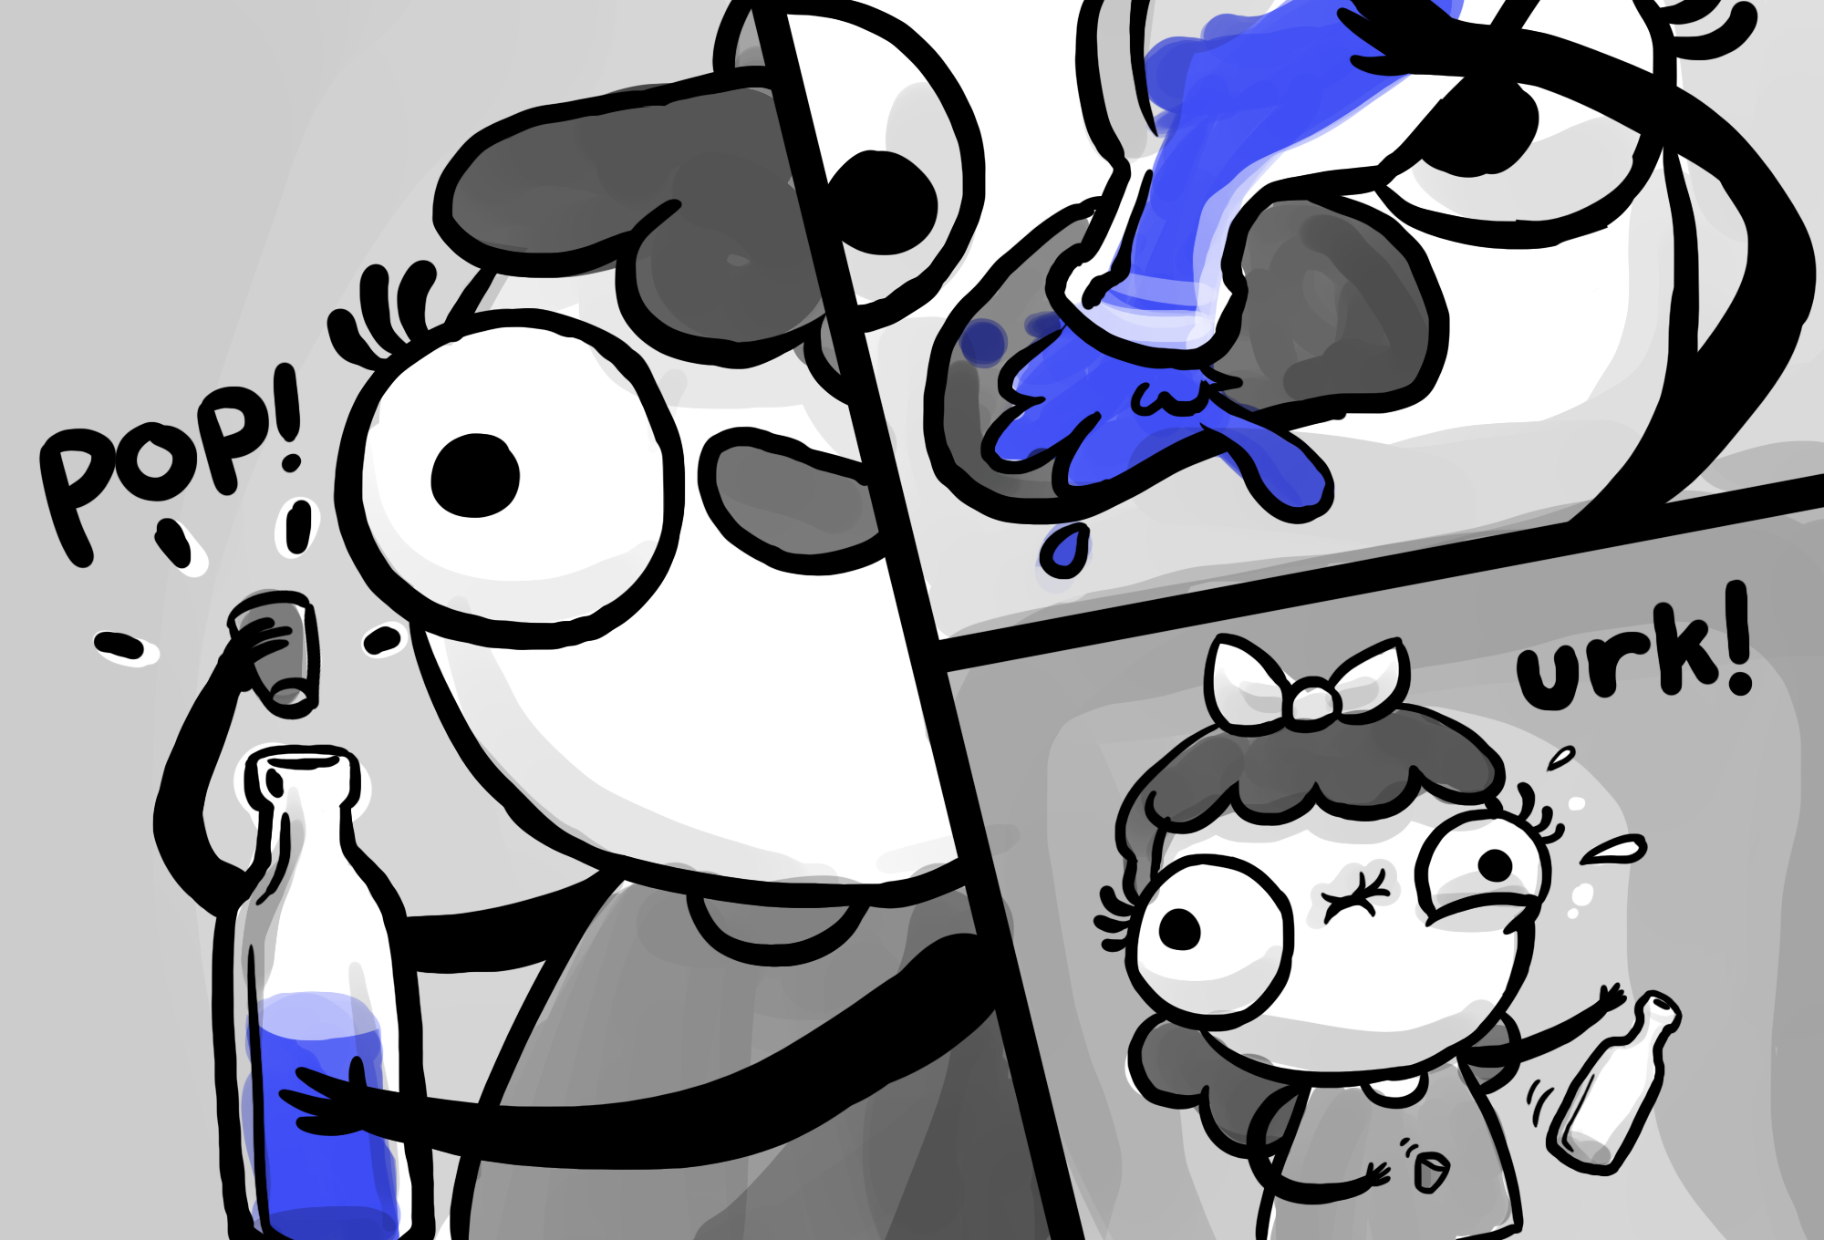

## Images and Text

We use almost all types of text-image interactions within our project, with the exception of parallel.

|  |  |
| --- | --- |
| <First picture>  Word Specific  We use this mainly at the start and end of the story, in order to give a narration so readers can better understand the set up. | <Rabbit’s look of horror>  Picture Specific  Usually used to highlight a character’s emotion. Used together with closeups. |
| <Alice eyes lit up(Morpheus scene)>  Duo-Specific and Additive  Used when picture emphasizes the text. | Macintosh HD:Users:andrew:Wonderland:_images:cheshire:cheshire-1.png  Montage  Only used to incorporate sound effects into the drawings |
| <Dangerous to go alone take this>  Interdependant  We endeavored to ensure that majority of the panels were of this interaction. This allowed us to make better and fully use of text and images. | |

# Design and Layout

## Principle Design Concepts

After experiencing the design for both Assignements 3 and 4, the group was more inclined to follow through with a similar design to Assignment 4 as we felt it would be more compatible with the concept of choice and the multipath narrative struture. Thus, we decided to maintain the 1000 by 680 pixel aspect ratio of each page.

## Compositions

Though most of the panels were drawn with a neutral shots(rather than high or low angles), close-up shots were used a lot in the project. Close-up shots allowed us to bring the reader’s attention to the details on the character’s faces and thus be able to sense the nuances in the character’s expressions, thus giving a more wholesome and immersive experience to the readers.

<Need a close up>

Although most pages have single panels, pages with multiple panels will be placed in a conventional layout. In these cases, it is usally a moment to moment transition, and by placing the panels conventionally, readers will be able to better understand the action.

## Color Scheme

Due to the limitation of time as well as talent(only one of us is familiar with coloring), we decided that the color scheme of the project would be greyscale. Our artist, Wenhan, fills in the grey shades to give the pictures more substance as he draws.

# Components of Web Features

## Interactivity

The main interactive component of our project lies in the empowerment of the reader to choose a certain direction for the story. For that, we use two specific types of choices that give the reader that immersiveness.

<White rabbit help or no help panel>

### Dilemma

The first choice faced, whether to help the White Rabbit or not, is a classic example of a dilemma. With no indication of which action is the RIGHT action, the reader is then forced to make a choice based on his or her gut feel at that moment. There are also several choices within the story that call for the reader to make an uninformed decision that can affect the final outcome of the story.

### False Choices

Truthfully speaking, the type of choice that is used most prominently in our project. Every time the reader makes a choice that ends up in the ‘death’ of Alice, it will eventually lead back to the start, making it a false choice. In fact, since all choices eventually lead to the Tea Party Scene, it can be said that all choices prior to that scene are actually false choices.

## Sound and Audio

As a group, we agreed that sound and animation would be minimal, and would serve more as a supportive rather than an active role in our story.

As such, majority of the audio is background sound. Specific scenes would have a relevant sound assigned to it, and whenever each scene is showing, the corresponding back ground sound would play. One example is the crackling of the fireplace that plays when in any panel with Alice back at home.

Another way we utilise sound is in certain sound effects to enhance the actions. One example is when Alice falls onto the Cheshire. An audio plays when the reader reaches the end of the scroll. This, coupled with the animation, give the reader a better satisfaction and sense of empowerment.

## Animation

We had originally decided that animations, if present, would only exist as gif loops within the story, mainly due to the experiences we encountered with the readings from lecture, as we felt too many animations would remove reader control.

However, we subsequently realised that certain animations could help enhance the reader’s experience without removing control from them. One such animation is linked to the scroll. At certain panels, scrolling will trigger an animation within the panel. This gives the reader a beter control over the story.

In addition, we realised the benefits of using small animation gifs to help highlight choices given to the reader. One such example are the pills Morpheus offers. By hovering over each choice, the animation will show the reader that it can be interacted with.

# Tools and Techniques

Html, CSS, JavaScript, JQuery etc.

# Testing and Deployment

## Initial Testing

Our initial testing was done during one of the lecture slots. A total of 14 participants were tested. All the participants were from the NM3228 lecture, and thus were familiar with key concepts of sequential art.

We invited the participants to navigate through the comic by themselves. During this time, we would observe them to see how they were able to interact with our project. Once they were done, we would interview them.

## Key Observations

* Readers did not realize they had to scroll when they reached the animation.
* Certain choices were not clear to readers.
* Readers were confused about where to click at the Queen’s dungeon.
* Readers found it tiresome that they had to start from the beginning if they lost to the Queen.
* Readers had problems navigating the Hallway Scene
* Readers felt the use of sound effects were apt.

## Insights

* + As majority of the panels are managed by just clicking, we realized that readers take some time to react to the sudden change of needing to scroll. Thus, there is a need for some form of indication.
  + As we did not intend for any choices to be hidden, choices need to be clear.
  + A reader who does not know how a system works will be very unlikely to click the SAME button multiple times. They would be more likely to give up.

## Changes Made

* + - As the falling scene is the first scene that is in need of scrolling, we changed the text to give the users a hint that they are required to scroll.
    - All choices now have either an animation or change in appearance to show that they are choices(even the items to collect). It also helps the reader to ensure they do not accidentally click the wrong choice.
    - The Hallway Scene has been reduced to two clicks rather than six.

## Follow Up Testing

As changes were made to the project following the initial testing, we continued to test the project in the same manner with different people who are not part of the class. All issues found in the initial testing were subsequently removed with each iteration.

# Reflection

## Problems encountered

One major problem encountered was the lack of a CNM student. As majority of the group were CS students, we were not familiar with the grading criteria of NM modules, and even more unfamiliar with writing reports similar to the final report. However, we made up for that weakness by turning it into a strength, using our familiarity with code to maximise the smoothness and ‘wow’ factor of our comic.

Another issue was that only one of us was artistically inclined. The difference in artistic talent became apparent and thus we found it difficult to split the drawings amongst ourselves, as the quality in drawing differed so drastically. In the end, Wenhan put in a lot of effort to draw all 90 panels himself, whilst the rest of us worked on the other sections of the project(code, animations, etc.)

## Lessons gained

One lesson gained is in the

## Transferable Knowledge and Skills

(how can you transfer what you have learned to other disciplines)